Key Stakeholder Mapping and Tension Maps of the Social Structure of the Bovine and Pork Livestock Sectors in Mexico.

MESA México Coordination:
Dr. Elena Lazos-Chavero (IIS-UNAM).
Rebeca Pérez-Flores.
Research Assistant.

Introduction.

Context of the livestock industry in Mexico.
The bovine and pork livestock industry in Mexico represents a system of high structural complexity characterized by the coexistence of highly technified transnational mega-companies with thousands of traditional small producers. The bovine and pork sectors jointly contribute 49.7% of national meat production and 2.3% of national GDP (COMECARNE, 2025), configuring a web of social relations marked by environmental, territorial, economic and animal welfare tensions that require systematic analysis to understand the power and conflict dynamics that structure these productive systems.
Given the critical differences between the bovine and pork sectors in terms of productive structure (self-sufficiency vs import dependency), business concentration, dominant actors and specific dynamics of territorial conflict, an independent Key Stakeholder Mapping (KSM) was developed for each sector. This methodological decision allows capturing the structural particularities and specific tensions of each system, recognizing that the bovine sector maintains relative productive balance with oligopolistic concentration, while the pork sector exhibits structural import dependency (46.7% of consumption) and significant presence of foreign capital with differentiated territorial impacts.

Key stakeholder mapping methodology (Tapella, 2007).
The present mapping is based on the Key Stakeholder Mapping (KSM) methodology developed by Tapella (2007), a tool widely used for social network analysis in development and research projects. KSM allows representing social reality as a web of relationships among actors, where the position they occupy in networks determines their values, influence capacities and behaviors. This methodology rests on the assumption that society can be understood in terms of structures that manifest through relationships among social actors, whether individuals, groups, organizations or institutions.
The classification of actors was carried out at four levels according to their capacity for influence and decision-making power over the livestock sector:
N1 - Decision-makers: Governmental actors with direct regulatory power, capacity to establish binding norms and authority to sanction. Includes state secretariats, attorney's offices and federal commissions with specific legal attributions over livestock production, health, environment and food safety.
N2 - Influencers: Organizations that shape sectoral dynamics without formal decision-making power. Comprises business chambers, trade confederations, unions, commercial associations, technical institutions and civil society organizations with capacity for pressure, interest representation and consensus generation that influence public policies and productive practices.
N3 - Base producers: Productive actors who contribute to the sector without significant political influence. Includes rural production societies, cooperatives, rural communities and indigenous communities whose participation is mainly productive, with limited capacity for impact on regulations or sectoral policies.
N4 - Resistance actors: Organizations and movements that oppose or question the established industrial livestock system. Comprises international and national environmental organizations, animal rights defenders, abolitionist movements, indigenous territorial resistances, plant-based food enterprises, and sanctuaries that represent alternative visions to the dominant productive model.
The identification and classification of the 36 actors in the bovine sector and 35 in the pork sector was carried out through systematic review of official documentary sources (COMECARNE, SIAP-SADER, SENASICA, SEMARNAT), analysis of specialized press for cases of territorial and environmental conflict (La Jornada, El Financiero, Infobae), and accumulated sectoral knowledge of the research team. This methodological approach allowed building a robust mapping that identifies not only the presence of actors, but their functions, interests and influence capacities within the web of relationships of the Mexican livestock sector.

Tension mapping: methodological proposal of MESA México.
Tension mapping constitutes an original methodological proposal developed by MESA México to complement Tapella's KSM through systematic visualization of conflictive relationships among actors. This tool is inspired by TABLE's approach (The Food Climate Research Network) for the analysis of values, evidence and conflicts in debates about food systems, adapting to the specific complexity of Mexican industrial livestock.
Tensions were classified into three intensity levels according to conflict magnitude, confrontation frequency and escalation potential:
High intensity: Structural conflicts between actors with fundamentally opposed interests, characterized by direct confrontation, public denunciations, litigation or mobilizations. Include tensions between environmental regulators and mega-producers for regulatory non-compliance, between animal defense organizations and all levels of livestock production, and between indigenous territorial resistances and companies operating in their territories.
Medium intensity: Inter-institutional coordination tensions, approach differences between actors of the same sector, or conflicts over resource access that have not escalated to open confrontation but represent recurring friction points.
Low intensity: Commercial competition, minor strategic differences, or latent tensions with low current conflict level but that could intensify under certain conditions.
The mapping identified 76 tensions in the bovine sector and 69 in the pork sector, revealing differentiated patterns of conflict. In the pork sector, the critical tension stands out as Maya territorial resistance (Stilpech, Chapab, Consejo Maya Chik'in Ja', La Red To'one) against mega-farms, particularly Kekén in Yucatán, representing a conflict of territorial defense, water access and cenote contamination that transcends the merely productive to become a struggle for autonomy and cultural survival.
Below are the KSMs and Tension Maps of each sector as well as tables with information regarding each actor and the enumeration and explanation of the tensions found.

Bovine sector.

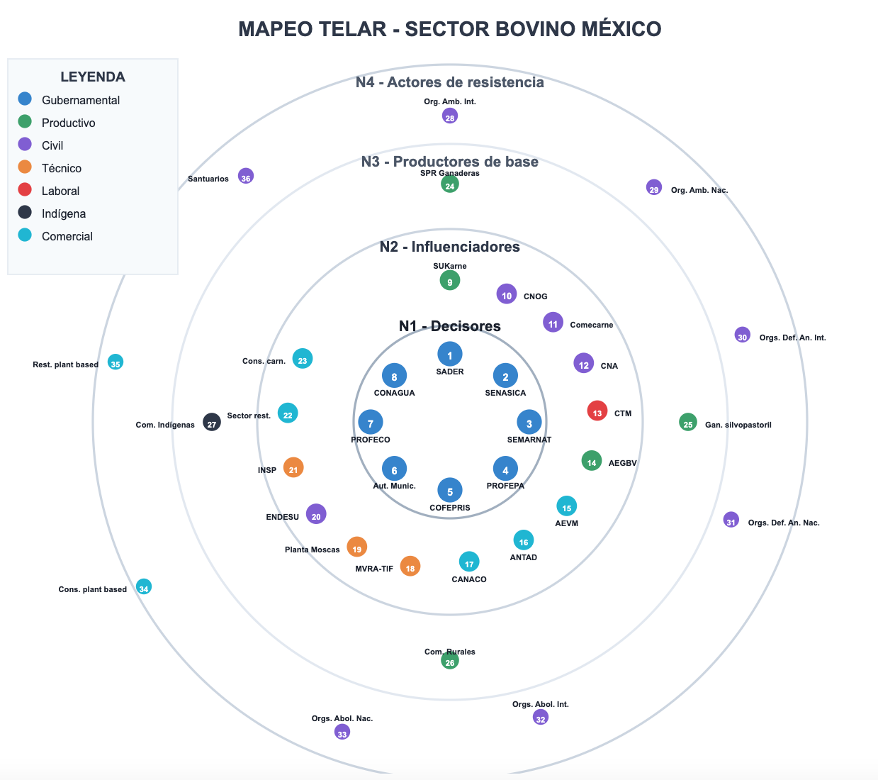

Actor structure by level.
# | Actor | Sector | Function | Organizations/Representative Groups
1 | SADER | Governmental | National agricultural policy and productive promotion | Secretariat of Agriculture and Rural Development
2 | SENASICA | Governmental | Sanitary and zoosanitary control and surveillance | National Service for Agrifood Health, Safety and Quality
3 | SEMARNAT | Governmental | Environmental regulation and territorial planning | Secretariat of Environment and Natural Resources
4 | PROFEPA | Governmental | Enforcement of environmental regulations | Federal Attorney for Environmental Protection
5 | COFEPRIS | Governmental | Sanitary regulation and food safety control | Federal Commission for the Protection against Sanitary Risks
6 | Municipal Auth. | Governmental | Local regulation, permits and territorial planning | Municipal Authorities
7 | PROFECO | Governmental | Consumer protection and commercial verification | Federal Attorney's Office of the Consumer
8 | CONAGUA | Governmental | Management and regulation of water resources | National Water Commission

N2 - INFLUENCERS.

# | Actor | Sector | Function | Organizations/Representative Groups
9 | SUKarne | Productive | Industrial beef production and processing | SUKarne
10 | CNOG | Civil | Representation and lobbying of organized ranchers | National Confederation of Livestock Organizations
11 | Comecarne | Civil | Commercialization and distribution of meat products | Mexican Meat Council
12 | CNA | Civil | Peasant representation and defense of small producers | National Peasant Confederation
13 | CTM | Labor | Union representation of slaughterhouse and processing plant workers | Confederation of Mexican Workers
14 | AEGBV | Productive | Representation of bovine cattle fatteners in Veracruz | Association of Bovine Cattle Fatteners of the State of Veracruz and Neighboring Municipalities
15 | AEVM | Commercial | Vegan entrepreneurship and plant-based alternatives | Association of Vegan Entrepreneurs Mexico
16 | ANTAD | Commercial | Retail and commercial distribution of meat products | National Association of Supermarkets and Department Stores
17 | CANACO | Commercial | Organized commerce and business chambers | National Confederation of Chambers of Commerce
18 | MVRA-TIF | Technical | Sanitary certification in Federal Inspection Type slaughterhouses | Authorized Responsible Veterinarians - TIF
19 | Fly Plant | Technical | Biological control of livestock pests (screw-worm fly) | Sterile Fly Production Plant
20 | ENDESU | Civil | Advocacy for economic, social and cultural rights | Team for Community Studies and Psychosocial Action
21 | INSP | Technical | Public health and sanitary risks research | National Institute of Public Health
22 | Rest. sector | Commercial | Commercial demand for bovine meat products | Carnist restaurants
23 | Carn. consumers | Commercial | Traditional consumption demand for beef | Carnist consumers
N3 - BASE PRODUCERS.

# | Actor | Sector | Function | Organizations/Representative Groups
24 | Livestock SPRs | Productive | Organized livestock production in cooperatives | Rural Production Societies - Livestock
25 | Silvopastoral Rch. | Productive | Sustainable low-impact productive model | Ranch "Las Margaritas"
26 | Rural Communities | Productive | Backyard and subsistence livestock in rural communities | Rural Communities
27 | Indigenous Com. | Indigenous | Traditional indigenous subsistence livestock | Indigenous Communities

N4 - RESISTANCE ACTORS.

# | Actor | Sector | Function | Organizations/Representative Groups
28 | Int. Env. Orgs. | Civil | Environmental activism against impacts of industrial livestock | Greenpeace, WWF
29 | Nat. Env. Orgs. | Civil | National environmental activism for conservation and sustainability | CEMDA, Natura Mexicana, Oxfam México
30 | Int. An. Def. Orgs. | Civil | Campaigns for welfare and rights of farmed animals | Igualdad Animal, AnimaNaturalis, Mercy for Animals, Pollination Project
31 | Nat. An. Def. Orgs. | Civil | National animal defense against mistreatment in production | CODAM, Liberum AC, APASDEM AC
32 | Int. Abol. Orgs. | Civil | International animal abolitionism against exploitation | DxE, Anonymous for the Voiceless
33 | Nat. Abol. Orgs. | Civil | National abolitionist movement to end speciesism | March Against Speciesism, GIDA
34 | Plant-based Cons. | Commercial | Demand for plant-based alternatives that reduces and eliminates meat consumption | Plant-based consumers
35 | Plant-based Rest. | Commercial | Commercial offer of plant-based alternatives to meat products | Plant-based restaurants
36 | Sanctuaries | Civil | Rescue and protection of animals from the livestock system | Santuario Libres al Fin, Santuario Tierra de Animales

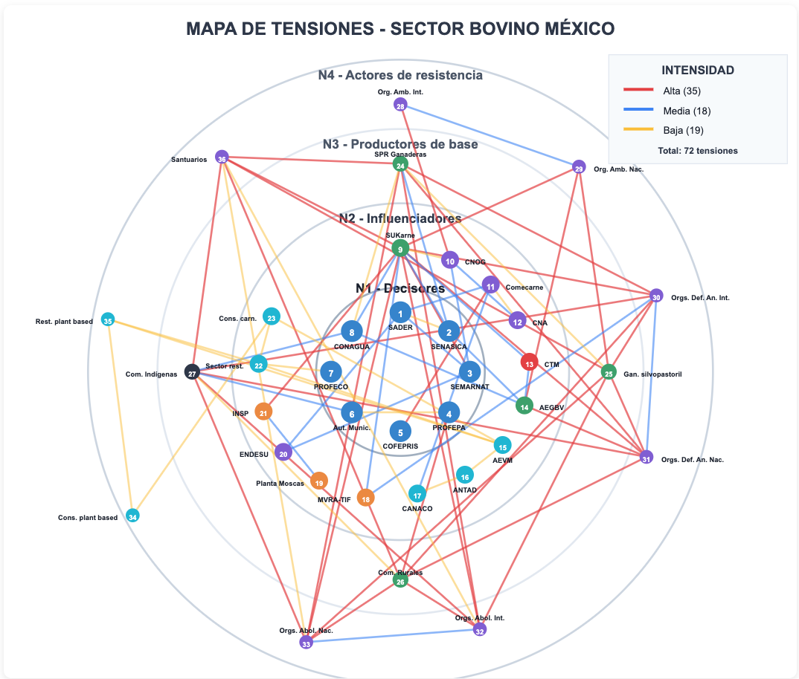

HIGH INTENSITY TENSIONS.

# | Actor 1 | Actor 2 | Tension Description
1 | SEMARNAT (#3, N1) | SUKarne (#9, N2) | Environmental regulation vs. intensive industrial production - Conflict over emissions, waste, and regulatory compliance
2 | PROFEPA (#4, N1) | Rural Com. (#26, N3) | Environmental surveillance vs. traditional productive practices - Sanctions for non-compliance
3 | Int. Env. Orgs. (#28, N4) | CNOG (#10, N2) | Greenpeace, WWF vs. livestock chamber - Questioning of industrial model and environmental footprint
4 | Nat. Env. Orgs. (#29, N4) | SUKarne (#9, N2) | National environmentalism vs. mega-producer - Pollution, water use, and deforestation
5 | Nat. Env. Orgs. (#29, N4) | Silvopastoral Rch. (#25, N3) | Questioning of livestock practices even alternative ones - Debate on environmental impact
6 | Nat. Env. Orgs. (#29, N4) | AEGBV (#14, N2) | Environmentalists vs. Veracruz fatteners - Impact on local ecosystems
7 | Int. An. Def. Orgs. (#30, N4) | SUKarne (#9, N2) | International animal defense vs. meat industry - Animal welfare in mega-farms
8 | Int. An. Def. Orgs. (#30, N4) | Livestock SPRs (#24, N3) | Questioning of animal welfare in livestock cooperatives
9 | Int. An. Def. Orgs. (#30, N4) | Silvopastoral Rch. (#25, N3) | Debate on welfare in alternative production systems
10 | Int. An. Def. Orgs. (#30, N4) | Rural Com. (#26, N3) | Tension over traditional practices vs. animal welfare standards
11 | Int. An. Def. Orgs. (#30, N4) | Indigenous Com. (#27, N3) | Cultural conflict over human-animal relationship and livestock practices
12 | Nat. An. Def. Orgs. (#31, N4) | SUKarne (#9, N2) | Igualdad Animal, AnimaNaturalis vs. industrial production - Exposure of mistreatment
13 | Nat. An. Def. Orgs. (#31, N4) | Livestock SPRs (#24, N3) | Questioning of conditions in producer cooperatives
14 | Nat. An. Def. Orgs. (#31, N4) | Silvopastoral Rch. (#25, N3) | Debate on welfare in silvopastoral models
15 | Nat. An. Def. Orgs. (#31, N4) | Rural Com. (#26, N3) | Tension over welfare standards vs. community resources
16 | Nat. An. Def. Orgs. (#31, N4) | Indigenous Com. (#27, N3) | Conflict between animal rights and traditional cultural practices
17 | Nat. An. Def. Orgs. (#31, N4) | AEGBV (#14, N2) | National organizations vs. fatteners - Confinement conditions
18 | Int. Abol. Orgs. (#32, N4) | SUKarne (#9, N2) | Abolitionist movement vs. industry - Total rejection of animal exploitation
19 | Int. Abol. Orgs. (#32, N4) | Livestock SPRs (#24, N3) | Abolitionist vision vs. cooperative production
20 | Int. Abol. Orgs. (#32, N4) | Silvopastoral Rch. (#25, N3) | Rejection of all forms of livestock including alternatives
21 | Int. Abol. Orgs. (#32, N4) | Rural Com. (#26, N3) | Ideological clash over use of animals for food
22 | Int. Abol. Orgs. (#32, N4) | Indigenous Com. (#27, N3) | Tension between abolitionism and indigenous worldview on animals
23 | Nat. Abol. Orgs. (#33, N4) | SUKarne (#9, N2) | National abolitionist activism against mega-producer
24 | Nat. Abol. Orgs. (#33, N4) | Livestock SPRs (#24, N3) | Animal liberation movement vs. livestock cooperatives
25 | Nat. Abol. Orgs. (#33, N4) | Silvopastoral Rch. (#25, N3) | Abolitionist rejection of regenerative models with animals
26 | Nat. Abol. Orgs. (#33, N4) | Rural Com. (#26, N3) | Conflict over end of livestock vs. rural sustenance
27 | Nat. Abol. Orgs. (#33, N4) | Indigenous Com. (#27, N3) | Tension between abolitionism and indigenous food autonomy
28 | Sanctuaries (#36, N4) | SUKarne (#9, N2) | Santuario Libres al Fin vs. industry - Animal rescue and denunciation
29 | Sanctuaries (#36, N4) | Livestock SPRs (#24, N3) | Sanctuaries as alternative vs. cooperative production
30 | Sanctuaries (#36, N4) | Silvopastoral Rch. (#25, N3) | Sanctuary model vs. use of animals in silvopastoral systems
31 | Sanctuaries (#36, N4) | Rural Com. (#26, N3) | Tension between animal rescue and subsistence livestock
32 | Sanctuaries (#36, N4) | Indigenous Com. (#27, N3) | Conflict over animal liberation vs. traditional practices
33 | INSP (#21, N2) | SUKarne (#9, N2) | Public health institute vs. industry - Sanitary risks of intensive production
34 | COFEPRIS (#5, N1) | Comecarne (#11, N2) | Sanitary regulation vs. chamber of marketers - Food safety
35 | SEMARNAT (#3, N1) | PROFEPA (#4, N1) | Inter-institutional coordination - Tension between environmental policy formulation vs. surveillance and sanction

MEDIUM INTENSITY TENSIONS.

# | Actor 1 | Actor 2 | Tension Description
36 | SENASICA (#2, N1) | Livestock SPRs (#24, N3) | Sanitary control vs. productive autonomy of livestock cooperatives
37 | SENASICA (#2, N1) | SUKarne (#9, N2) | Zoosanitary regulation vs. industrial productive pressure
38 | SENASICA (#2, N1) | AEGBV (#14, N2) | Sanitary standards vs. fatteners - Certifications and restrictions
39 | SEMARNAT (#3, N1) | CNOG (#10, N2) | Environmental policy vs. livestock chamber - Regulation of environmental impact
40 | SADER (#1, N1) | Comecarne (#11, N2) | Agricultural policy vs. interests of meat marketers
41 | SADER (#1, N1) | SEMARNAT (#3, N1) | Agricultural development vs. environmental conservation - Structural government conflict
42 | CNOG (#10, N2) | CNA (#12, N2) | Tension between livestock chamber and agricultural council - Sector representation
43 | INSP (#21, N2) | Fly Plant (#19, N2) | Public health vs. biological pest control - Sanitary coordination
44 | Int. Env. Orgs. (#28, N4) | Nat. Env. Orgs. (#29, N4) | Coordination and strategic differences between international and national environmentalism
45 | Int. An. Def. Orgs. (#30, N4) | Nat. An. Def. Orgs. (#31, N4) | Tension between international vs. national animal defense strategies
46 | Int. Abol. Orgs. (#32, N4) | Nat. Abol. Orgs. (#33, N4) | Differences in approach between international and national abolitionism
47 | CTM (#13, N2) | AEGBV (#14, N2) | Union confederation vs. fatteners - Labor conflict over working conditions
48 | CTM (#13, N2) | SUKarne (#9, N2) | Union vs. mega-producer - Labor rights, safety, and wages
49 | CONAGUA (#8, N1) | Indigenous Com. (#27, N3) | Water management vs. indigenous communities - Access and water concessions
50 | CONAGUA (#8, N1) | SUKarne (#9, N2) | Intensive industrial water use vs. water availability and regulation
51 | CONAGUA (#8, N1) | AEGBV (#14, N2) | Fatteners require large volumes of water vs. regional scarcity
52 | Municipal Auth. (#6, N1) | Indigenous Com. (#27, N3) | Local authorities vs. indigenous autonomy - Permits and territorial regulation
53 | ENDESU (#20, N2) | SEMARNAT (#3, N1) | Social rights approach vs. environmental policy - Development priorities
54 | ENDESU (#20, N2) | SADER (#1, N1) | Social rights vs. productivist approach of agricultural policy
55 | MVRA-TIF (#18, N2) | Int. An. Def. Orgs. (#30, N4) | Certifying veterinarians vs. animal defense organizations - Differences over standards
56 | MVRA-TIF (#18, N2) | SUKarne (#9, N2) | Sanitary certifiers vs. industrial productive pressure
57 | CANACO (#17, N2) | Comecarne (#11, N2) | General commerce chamber vs. meat marketers - Commercial competition

LOW INTENSITY TENSIONS.

# | Actor 1 | Actor 2 | Tension Description
58 | SADER (#1, N1) | SENASICA (#2, N1) | Coordination between agricultural policy and animal health
59 | CONAGUA (#8, N1) | Livestock SPRs (#24, N3) | Cooperative producers require water vs. availability
60 | Municipal Auth. (#6, N1) | PROFEPA (#4, N1) | Coordination between local authorities and environmental attorney's office
61 | SUKarne (#9, N2) | CNOG (#10, N2) | Mega-producer vs. livestock chamber - Differences in scale and interests
62 | Comecarne (#11, N2) | CNA (#12, N2) | Marketers vs. agricultural council - Sectoral coordination
63 | AEVM (#15, N2) | ANTAD (#16, N2) | Vegan entrepreneurs vs. supermarket retail - Competition for shelf space
64 | AEVM (#15, N2) | Rest. sector (#22, N2) | Vegan entrepreneurs vs. carnist restaurants - Commercial competition for food market
65 | AEVM (#15, N2) | Carn. consumers (#23, N2) | Ideological/cultural tension over food choices
66 | AEVM (#15, N2) | Plant-based Rest. (#35, N4) | Alliance/coordination between vegan entrepreneurs and plant-based restaurants
67 | ANTAD (#16, N2) | CANACO (#17, N2) | Supermarket retail vs. commercial chambers - Commercial competition
68 | Rest. sector (#22, N2) | Carn. consumers (#23, N2) | Economic tension between restaurant supply and consumer demand
69 | Plant-based Cons. (#34, N4) | Plant-based Rest. (#35, N4) | Differences over strategies, prices, and authenticity of the plant-based movement
70 | Livestock SPRs (#24, N3) | Silvopastoral Rch. (#25, N3) | Traditional cooperatives vs. regenerative model - Differences in productive approach
71 | Rural Com. (#26, N3) | Indigenous Com. (#27, N3) | Differences between mestizo rural and indigenous communities over territory and resources
72 | PROFECO (#7, N1) | Rest. sector (#22, N2) | Consumer protection vs. restaurant sector - Verification of prices and quality
73 | Sanctuaries (#36, N4) | Int. Abol. Orgs. (#32, N4) | ALLIANCE - Strategic collaboration between sanctuaries and international abolitionist movement
74 | Sanctuaries (#36, N4) | Nat. Abol. Orgs. (#33, N4) | ALLIANCE - Coordination between sanctuaries and national abolitionism
75 | Carn. consumers (#23, N2) | Plant-based Cons. (#34, N4) | Ideological/cultural tension over carnist vs. vegetarian food choices
76 | Rest. sector (#22, N2) | Plant-based Rest. (#35, N4) | Commercial competition between traditional and plant-based restauran

Pork sector.

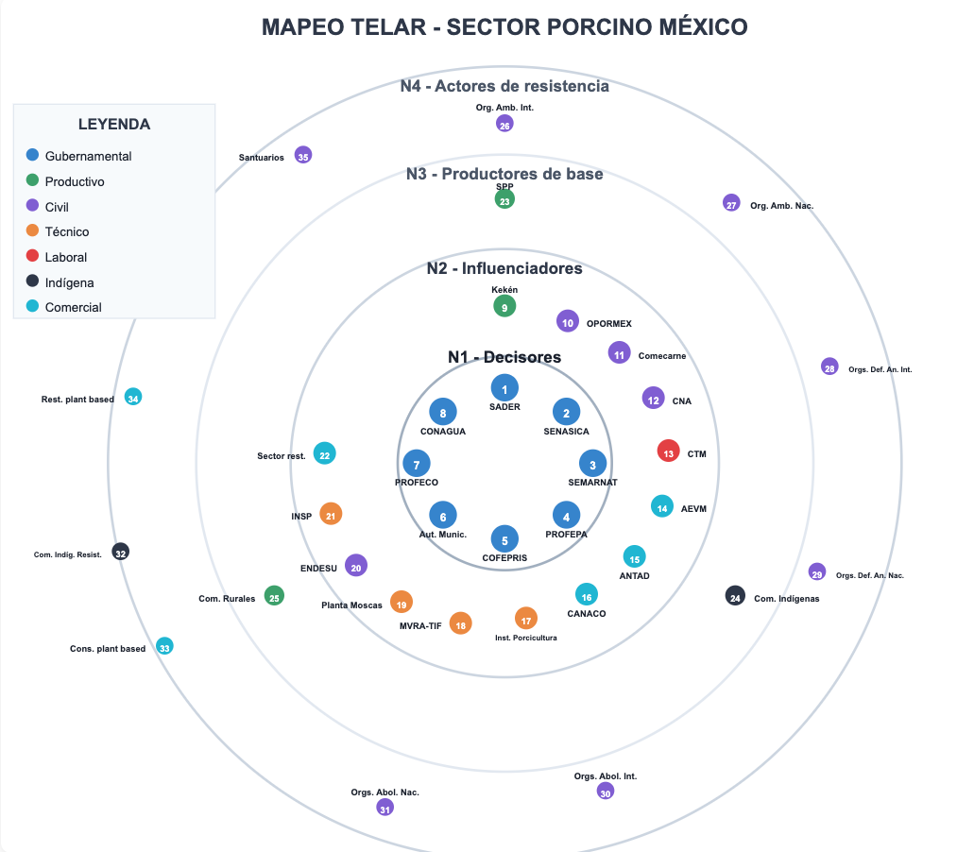

Actor structure by level.
N1 - DECISION-MAKERS.

# | Actor | Sector | Function | Organizations/Representative Groups
1 | SADER | Government | Public agricultural policy and porcine development | Secretariat of Agriculture and Rural Development
2 | SENASICA | Government | Porcine and zoosanitary sanitary control | National Service for Agrifood Health, Safety and Quality
3 | SEMARNAT | Government | Environmental regulation of pig farms | Secretariat of Environment and Natural Resources
4 | PROFEPA | Government | Environmental surveillance and sanction | Federal Attorney for Environmental Protection
5 | COFEPRIS | Government | Pork meat safety | Federal Commission for the Protection against Sanitary Risks
6 | Municipal Auth. | Government | Local regulation and operating permits | Municipal authorities (Yucatán, Jalisco, Sonora, Guanajuato)
7 | PROFECO | Government | Consumer protection of pork products | Federal Attorney's Office of the Consumer
8 | CONAGUA | Government | Management of water resources for pig farming | National Water Commission

N2 - INFLUENCERS.

# | Actor | Sector | Function | Organizations/Representative Groups
9 | Kekén | Productive | Industrial large-scale porcine production | Kekén (Mexican Porcine Group) - National leader
10 | OPORMEX | Civil | Guild representation of pig farmers | Organization of Mexican Pig Farmers
11 | Comecarne | Civil | Commercialization and distribution of pork meat | National Chamber of the Meat Industry
12 | CNA | Civil | Intersectoral agricultural representation | National Agricultural Council
13 | CTM | Labor | Union representation of porcine workers | Confederation of Mexican Workers
14 | AEVM | Commercial | Commercial vegan ventures | Association of Vegan Entrepreneurs Mexico
15 | ANTAD | Commercial | Retail distribution of pork products | National Association of Supermarkets and Department Stores
16 | CANACO | Commercial | General commerce of meat products | National Chamber of Commerce, Services and Tourism
17 | Porc. Inst. | Technical | Porcine research and technical development | Porcine Research Institute
18 | MVRA-TIF | Technical | TIF sanitary certification of pork products | Authorized Responsible Veterinarians - Federal Inspection Type
19 | Fly Plant | Technical | Biological control of pests in pig farming | Sterile fly production plant
20 | ENDESU | Civil | Sustainable development and social rights | Enlace, Comunicación y Capacitación A.C.
21 | INSP | Technical | Public health and food research | National Institute of Public Health
22 | Rest. sector | Commercial | Pork meat consumption in traditional restaurants | Carnist restaurants

N3 - BASE PRODUCERS.

# | Actor | Sector | Function | Organizations/Representative Groups
23 | SPP | Productive | Cooperatives and small organized producers | Pork Product System (state cooperatives)
24 | Indigenous Com. | Indigenous | Traditional backyard pig farming | Indigenous producer communities (Yucatán, Chiapas, Oaxaca)
25 | Rural Communities | Productive | Subsistence and small-scale pig farming | Mestizo rural producer communities

N4 - RESISTANCE ACTORS.

# | Actor | Sector | Function | Organizations/Representative Groups
26 | Int. Env. Orgs. | Civil | Environmental activism against impacts of industrial pig farming | Greenpeace, WWF
27 | Nat. Env. Orgs. | Civil | Defense of local ecosystems against mega-farms | Mexican environmental organizations
28 | Int. An. Def. Orgs. | Civil | Defense of animal welfare in pig farming | International animal defense organizations
29 | Nat. An. Def. Orgs. | Civil | Campaigns against mistreatment in pig farms | Igualdad Animal México, AnimaNaturalis México
30 | Int. Abol. Orgs. | Civil | Total rejection of porcine exploitation | International abolitionist movement
31 | Nat. Abol. Orgs. | Civil | Abolition of pig farming and animal liberation | Mexican abolitionist movement
32 | Indig. Resist. Com. | Indigenous | Mayan territorial resistance against mega-farms | Stilpech, Chapab, Consejo Maya Chik'in Ja', La Red To'one
33 | Plant-based Cons. | Commercial | Demand for plant-based alternatives to pork meat | Vegan and plant-based consumers
34 | Plant-based Rest. | Commercial | Plant-based gastronomic offer without pork products | Vegan and vegetarian restaurants
35 | Sanctuaries | Civil | Rescue of pigs and anti-speciesist education | Santuario Libres al Fin, Santuario Seres Libres,

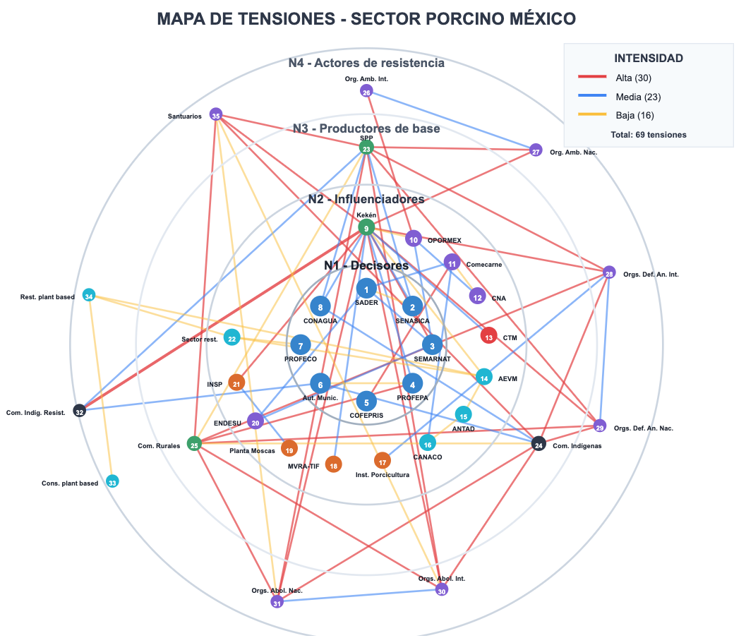

HIGH INTENSITY TENSIONS.

# | Actor 1 | Actor 2 | Tension Description
1 | SEMARNAT (#3, N1) | Kekén (#9, N2) | Environmental regulation vs. intensive industrial production - Conflict over emissions, porcine waste, and regulatory compliance
2 | PROFEPA (#4, N1) | Rural Com. (#25, N3) | Environmental surveillance and sanction vs. small-scale practices without compliance
3 | Int. Env. Orgs. (#26, N4) | OPORMEX (#10, N2) | Global ecological activism vs. guild representation defending industrial porcine model
4 | Nat. Env. Orgs. (#27, N4) | Kekén (#9, N2) | Defense of local ecosystems vs. pig mega-farms with severe environmental impact
5 | Nat. Env. Orgs. (#27, N4) | SPP (#23, N3) | Environmental protection vs. expansion of porcine cooperatives in ecologically sensitive zones
6 | Int. An. Def. Orgs. (#28, N4) | Kekén (#9, N2) | International animal welfare standards vs. intensive confinement industrial systems
7 | Int. An. Def. Orgs. (#28, N4) | SPP (#23, N3) | Global animal defense campaigns vs. traditional cooperative practices without certification
8 | Int. An. Def. Orgs. (#28, N4) | Rural Com. (#25, N3) | International animal protection vs. subsistence pig farming without welfare regulation
9 | Int. An. Def. Orgs. (#28, N4) | Indigenous Com. (#24, N3) | Animal rights vs. traditional backyard indigenous pig farming
10 | Nat. An. Def. Orgs. (#29, N4) | Kekén (#9, N2) | Denunciations of mistreatment in Mexican farms vs. industrial confinement practices
11 | Nat. An. Def. Orgs. (#29, N4) | SPP (#23, N3) | Campaigns against animal suffering vs. cooperatives without welfare protocols
12 | Nat. An. Def. Orgs. (#29, N4) | Rural Com. (#25, N3) | Local activism for animal defense vs. rural breeding without protection protocols
13 | Nat. An. Def. Orgs. (#29, N4) | Indigenous Com. (#24, N3) | Animal protection vs. traditional cultural porcine uses in indigenous communities
14 | Int. Abol. Orgs. (#30, N4) | Kekén (#9, N2) | Total rejection of animal exploitation vs. industrial porcine production model
15 | Int. Abol. Orgs. (#30, N4) | SPP (#23, N3) | Abolition of pig farming vs. organized cooperative productive system
16 | Int. Abol. Orgs. (#30, N4) | Rural Com. (#25, N3) | End of animal exploitation vs. peasant subsistence based on pig farming
17 | Int. Abol. Orgs. (#30, N4) | Indigenous Com. (#24, N3) | Animal liberation vs. indigenous productive and cultural traditions
18 | Nat. Abol. Orgs. (#31, N4) | Kekén (#9, N2) | Mexican abolitionist movement vs. industrial production leader
19 | Nat. Abol. Orgs. (#31, N4) | SPP (#23, N3) | Total abolition of production vs. organized pig farmer cooperatives
20 | Nat. Abol. Orgs. (#31, N4) | Rural Com. (#25, N3) | End of animal breeding vs. rural economy based on pig farming
21 | Nat. Abol. Orgs. (#31, N4) | Indigenous Com. (#24, N3) | Animal liberation vs. indigenous worldview and traditional practices
22 | Sanctuaries (#35, N4) | Kekén (#9, N2) | Rescue and protection of pigs vs. massive industrial production
23 | Sanctuaries (#35, N4) | SPP (#23, N3) | Anti-speciesist education vs. cooperative pig production model
24 | Sanctuaries (#35, N4) | Rural Com. (#25, N3) | Animal rescue vs. subsistence pig farming in rural communities
25 | Sanctuaries (#35, N4) | Indigenous Com. (#24, N3) | Protection of pigs vs. traditional indigenous breeding
26 | Indig. Resist. Com. (#32, N4) | Kekén (#9, N2) | Mayan territorial defense vs. mega-farms in Yucatán - Conflict over water, cenotes, and contamination
27 | Indig. Resist. Com. (#32, N4) | SPP (#23, N3) | Indigenous territorial resistance vs. expansion of porcine cooperatives in their lands
28 | Indig. Resist. Com. (#32, N4) | Municipal Auth. (#6, N1) | Mayan autonomy vs. local authorities granting permits to mega-farms
29 | INSP (#21, N2) | Kekén (#9, N2) | Public health research vs. sanitary risks of intensive pig farming
30 | COFEPRIS (#5, N1) | Comecarne (#11, N2) | Sanitary regulation vs. pork meat marketing interests
31 | SEMARNAT (#3, N1) | PROFEPA (#4, N1) | Inter-institutional coordination - Tension between environmental policy formulation vs. surveillance and sanction

MEDIUM INTENSITY TENSIONS.

# | Actor 1 | Actor 2 | Tension Description
32 | SENASICA (#2, N1) | SPP (#23, N3) | Sanitary control vs. productive autonomy of porcine cooperatives
33 | SENASICA (#2, N1) | Kekén (#9, N2) | Zoosanitary regulation vs. industrial productive pressure
34 | SEMARNAT (#3, N1) | OPORMEX (#10, N2) | Environmental policy vs. guild interests of pig farmers
35 | SADER (#1, N1) | Comecarne (#11, N2) | Agricultural policy vs. pork meat marketing interests
36 | SADER (#1, N1) | SEMARNAT (#3, N1) | Agricultural development vs. environmental conservation - Structural government conflict
37 | OPORMEX (#10, N2) | CNA (#12, N2) | Tension between pig farmers and agricultural council - Sector representation
38 | INSP (#21, N2) | Fly Plant (#19, N2) | Public health vs. biological pest control in pig farming
39 | Int. Env. Orgs. (#26, N4) | Nat. Env. Orgs. (#27, N4) | Coordination and strategic differences between international and national environmentalism
40 | Int. An. Def. Orgs. (#28, N4) | Nat. An. Def. Orgs. (#29, N4) | Tension between international vs. national animal defense strategies
41 | Int. Abol. Orgs. (#30, N4) | Nat. Abol. Orgs. (#31, N4) | Differences in approach between international and national abolitionism
42 | CTM (#13, N2) | Kekén (#9, N2) | Union confederation vs. mega-producer - Labor rights and working conditions
43 | CONAGUA (#8, N1) | Indigenous Com. (#24, N3) | Water management vs. indigenous communities - Access and water concessions
44 | CONAGUA (#8, N1) | Kekén (#9, N2) | Intensive industrial water use vs. water availability and regulation
45 | Municipal Auth. (#6, N1) | Indigenous Com. (#24, N3) | Local authorities vs. indigenous autonomy - Permits and territorial regulation
46 | ENDESU (#20, N2) | SEMARNAT (#3, N1) | Social rights approach vs. environmental policy - Development priorities
47 | ENDESU (#20, N2) | SADER (#1, N1) | Social rights vs. productivist approach of agricultural policy
48 | MVRA-TIF (#18, N2) | Int. An. Def. Orgs. (#28, N4) | Certifying veterinarians vs. animal defense organizations - Differences over standards
49 | MVRA-TIF (#18, N2) | Kekén (#9, N2) | Sanitary certifiers vs. industrial productive pressure
50 | CANACO (#16, N2) | Comecarne (#11, N2) | General commerce chamber vs. pork meat marketers - Commercial competition
51 | Indig. Resist. Com. (#32, N4) | Rural Com. (#25, N3) | Indigenous territorial defense vs. mestizo rural communities with porcine production
52 | Indig. Resist. Com. (#32, N4) | CONAGUA (#8, N1) | Mayan resistance vs. water commission - Conflict over water management and contamination of cenotes

LOW INTENSITY TENSIONS.

# | Actor 1 | Actor 2 | Tension Description
53 | SADER (#1, N1) | SENASICA (#2, N1) | Coordination between agricultural policy and animal health
54 | CONAGUA (#8, N1) | SPP (#23, N3) | Cooperative producers require water vs. availability
55 | Municipal Auth. (#6, N1) | PROFEPA (#4, N1) | Coordination between local authorities and environmental attorney's office
56 | Kekén (#9, N2) | OPORMEX (#10, N2) | Mega-producer vs. pig farmers guild - Differences in scale and interests
57 | Comecarne (#11, N2) | CNA (#12, N2) | Marketers vs. agricultural council - Sectoral coordination
58 | AEVM (#14, N2) | ANTAD (#15, N2) | Vegan entrepreneurs vs. supermarket retail - Competition for shelf space
59 | AEVM (#14, N2) | Rest. sector (#22, N2) | Vegan entrepreneurs vs. carnist restaurants - Commercial competition for food market
60 | AEVM (#14, N2) | Plant-based Rest. (#34, N4) | Alliance/coordination between vegan entrepreneurs and plant-based restaurants
61 | ANTAD (#15, N2) | CANACO (#16, N2) | Supermarket retail vs. commercial chambers - Commercial competition
62 | Rest. sector (#22, N2) | Plant-based Rest. (#34, N4) | Commercial competition between traditional and plant-based restaurants
63 | Plant-based Cons. (#33, N4) | Plant-based Rest. (#34, N4) | Differences over strategies, prices, and authenticity of the plant-based movement
64 | SPP (#23, N3) | Indigenous Com. (#24, N3) | Differences between organized cooperatives and traditional indigenous production
65 | Rural Com. (#25, N3) | Indigenous Com. (#24, N3) | Differences between mestizo rural and indigenous communities over territory and resources
66 | PROFECO (#7, N1) | Rest. sector (#22, N2) | Consumer protection vs. restaurant sector - Verification of prices and quality
67 | Sanctuaries (#35, N4) | Int. Abol. Orgs. (#30, N4) | ALLIANCE - Strategic collaboration between sanctuaries and international abolitionist movement
68 | Sanctuaries (#35, N4) | Nat. Abol. Orgs. (#31, N4) | ALLIANCE - Coordination between sanctuaries and national abolitionism
69 | Rest. sector (#22, N2) | Plant-based Rest. (#34, N4) | Commercial competition between traditional and plant-based restaurants

Bibliographic References.

Methodological Sources:

- Tapella, E. (2007). El mapeo de Actores Claves [Key Actor Mapping]. Working document of the project "Effects of functional biodiversity on ecosystem processes, ecosystem services and sustainability in the Americas: an interdisciplinary approach". Universidad Nacional de Córdoba, CONICET, Inter-American Institute for Global Change Research (IAI).
- Breewood, H. (2021). TABLE methodology: exploring values and assumptions in food systems debates. TABLE, University of Oxford.

Sectoral Data Sources:

- COMECARNE (2025). Compendio Estadístico 2025 [Statistical Compendium 2025]. Consejo Mexicano de la Carne. https://compendio2025.comecarne.org
- SIAP-SADER (2025). Cierre de la producción pecuaria 2024 [Closing of Livestock Production 2024]. Servicio de Información Agroalimentaria y Pesquera, Secretaría de Agricultura y Desarrollo Rural. https://nube.agricultura.gob.mx/cierre_pecuario/
- FAO (2022). The State of Food Security and Nutrition in the World 2022. Food and Agriculture Organization of the United Nations.
- CONEVAL (2022). Medición multidimensional de la pobreza en México 2022 [Multidimensional Poverty Measurement in Mexico 2022]. Consejo Nacional de Evaluación de la Política de Desarrollo Social.

Documentary Sources for Specific Cases:

- El Financiero (2024, June 25). Clausuran 1 de las 51 plantas de Granjas Carroll en Veracruz tras acusación por contaminar el agua [1 of the 51 Granjas Carroll Plants in Veracruz Closed After Accusation of Water Contamination]. https://www.elfinanciero.com.mx/estados/2024/06/25/clausuran-1-de-las-51-plantas-de-granjas-carroll-en-veracruz-tras-acusacion-por-contaminar-el-agua/
- La Jornada (2024, June 27). De 51 granjas Carroll que operan en Veracruz, sólo una ha sido clausurada [Of 51 Granjas Carroll Operating in Veracruz, Only One Has Been Closed]. https://www.jornada.com.mx/noticia/2024/06/27/estados/de-51-granjas-carroll-que-operan-en-veracruz-solo-una-ha-sido-clausurada-2095
- Infobae (2025, September 10). Clausuran megagranja porcícola tras años de contaminación y daños a la comunidad maya Santa María Chi en Yucatán [Pig Mega-Farm Closed After Years of Contamination and Damage to the Santa María Chi Maya Community in Yucatán]. https://www.infobae.com/mexico/2025/09/10/clausuran-megagranja-porcicola-tras-anos-de-contaminacion-y-danos-a-la-comunidad-maya-santa-maria-chi-en-yucatan/

